**THE SETTINGS OF BLACK MOUNTAIN**

**Modifications, Alterations or Additions to Existing Homes**

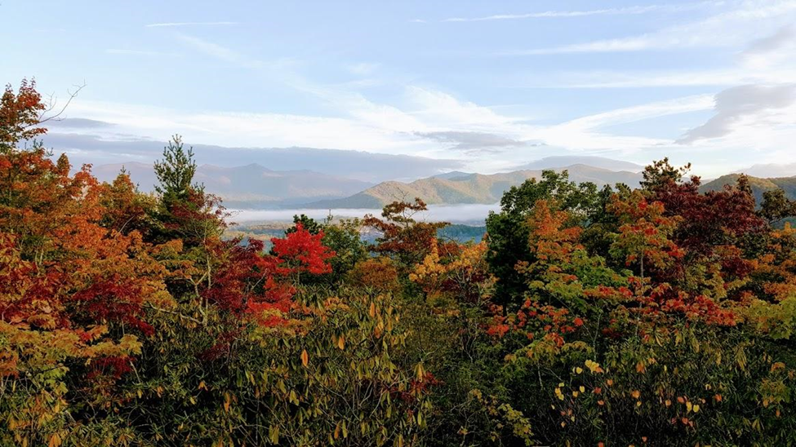

**Modifications, Alterations**

**or Additions to Existing Homes**

**The Architectural Guidelines and Construction Guidelines then in effect** **apply to any remodeling, additions or modifications to the house or landscape where exterior visual changes or hardscapes are involved.**

Any remodeling, additions or modifications to an existing house, accessory buildings, or landscape where exterior visual changes are involved require prior written DRB approval. This includes, but is not limited to, any additions, enlargements, exterior painting, the addition or modification of any decks, porches, patios, fire pits, awnings, roofing or exterior stairs, enclosures of existing decks or porches, tree removal, re-landscaping involving significant removal and/or replacement of plantings, hardscaping, the addition of solar equipment, pools, spas, satellite dishes, yard ornaments, and any changes to exterior lighting.

The replacement of existing items without any change in design or color does not require approval. Contractor approval by the DRB is not required.

In addition, changes to the interior of houses must retain garage capacity for at least two automobiles.

Working hour limitations set forth in the Construction Guidelines apply. No exterior work is permitted on weekdays before 8 AM or after 6 PM, on weekends or holidays.

Homeowners are required to submit to the DRB a completed Application for Residential Improvements, attached hereto as Appendix 1, with the submissions required by the Application. The DRB may, in its discretion, require the submission of architectural drawings or detailed written plans.

**Appendix 1**

**Application for Residential Improvements**

Submit Complete Applications to

The Settings DRB,

Email- DRB@tsobm.com

DATE

OWNERS NAME

PROPERTY ADDRESS___________________________________________LOT NUMBER_______

PHONE EMAIL

Project (check all that apply):

|  |  |  |  |
| --- | --- | --- | --- |
| Fence/Enclosure | Deck/Patio | Landscape Improvement | Play Equipment |
| Satellite Dish | Landscape Lighting | Pool/Spa | Exterior Paint color |
| Roof Change | Tree Removal | Other (Please Describe) |  |

**Describe proposed exterior improvement below:**





EXPECTED START DATE: EXPECTED COMPLETION DATE:

**THE FOLLOWING MUST BE SUBMITTED WITH THIS APPLICATION TO BE CONSIDERED COMPLETE:**

Official Lot Survey with sketched location of item or addition (if applicable)

Written description and color photos of materials to be used

Improvement specifications- measurements and dimensions- distances from property line and setback as applicable

Color photo of area to be improved

Construction/engineering plans as applicable

**WRITTEN APPROVAL FROM THE DRB IS REQUIRED PRIOR TO BEGINNING ANY PROJECT.**

**THE DRB HAS 30 DAYS FROM RECEIPT TO RESPOND TO ANY REQUEST. THE PROCESS DOES NOT BEGIN UNTIL ALL REQUIRED INFORMATION IS RECEIVED BY THE DRB.**

***NOTE:*** *APPROVAL BY THE DRB DOES NOT IN ANY WAY GUARANTEE APPROVALS BY THE TOWN, COUNTY, OR ANY OTHER SUCH AGENCIES, AND ALL SUCH APPROVALS OR PERMITS ARE THE RESPONSIBILITY OF THE APPLICANT. *IF YOUR COMMUNITY IS WITHIN A STREAM BUFFER AND THERE ARE ADDITIONAL RESTRICTIONS THAT APPLY, IT IS ENTIRELY THE OWNER’S RESPONSIBILITY. THE ASSOCIATION HAS NO RESPONSIBILITY OR LIABILITY FOR GOVERNMENT REQUIREMENTS.*

**The owner and builder acknowledge they have read the above information, Residential Improvement Guidelines, and the Association CC&Rs and DRB Guidelines, and agree to abide by the terms and conditions therein.**

Owner Date

DRB Approval___________________________________________ Date______________

Board Approval__________________________________________ Date______________